Lab 09c - Implement Azure Kubernetes Service.

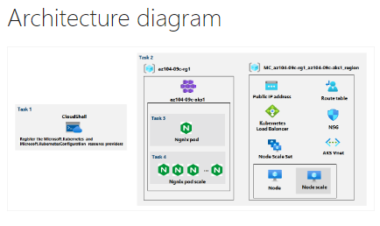

* Task 1: Register the Microsoft.Kubernetes and Microsoft.KubernetesConfiguration resource providers.
  + In this task, you will register resource providers necessary to deploy an Azure Kubernetes Services cluster.

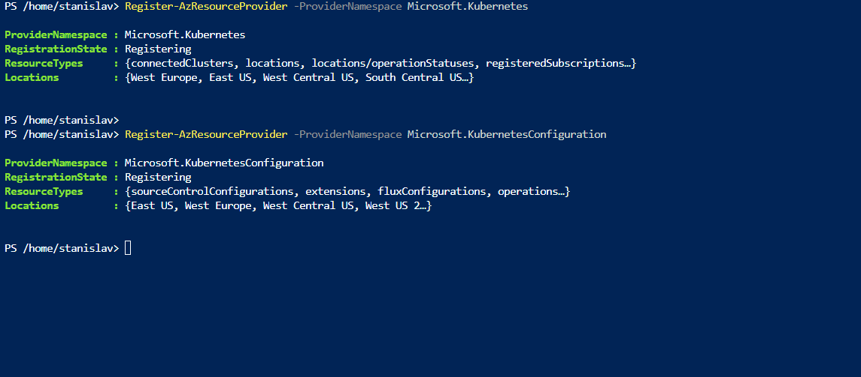

* + Register the Microsoft.Kubernetes and Microsoft.KubernetesConfiguration resource providers.
* Task 2: Deploy an Azure Kubernetes Service cluster.
  + In this task, you will deploy an Azure Kubernetes Services cluster by using the Azure portal.

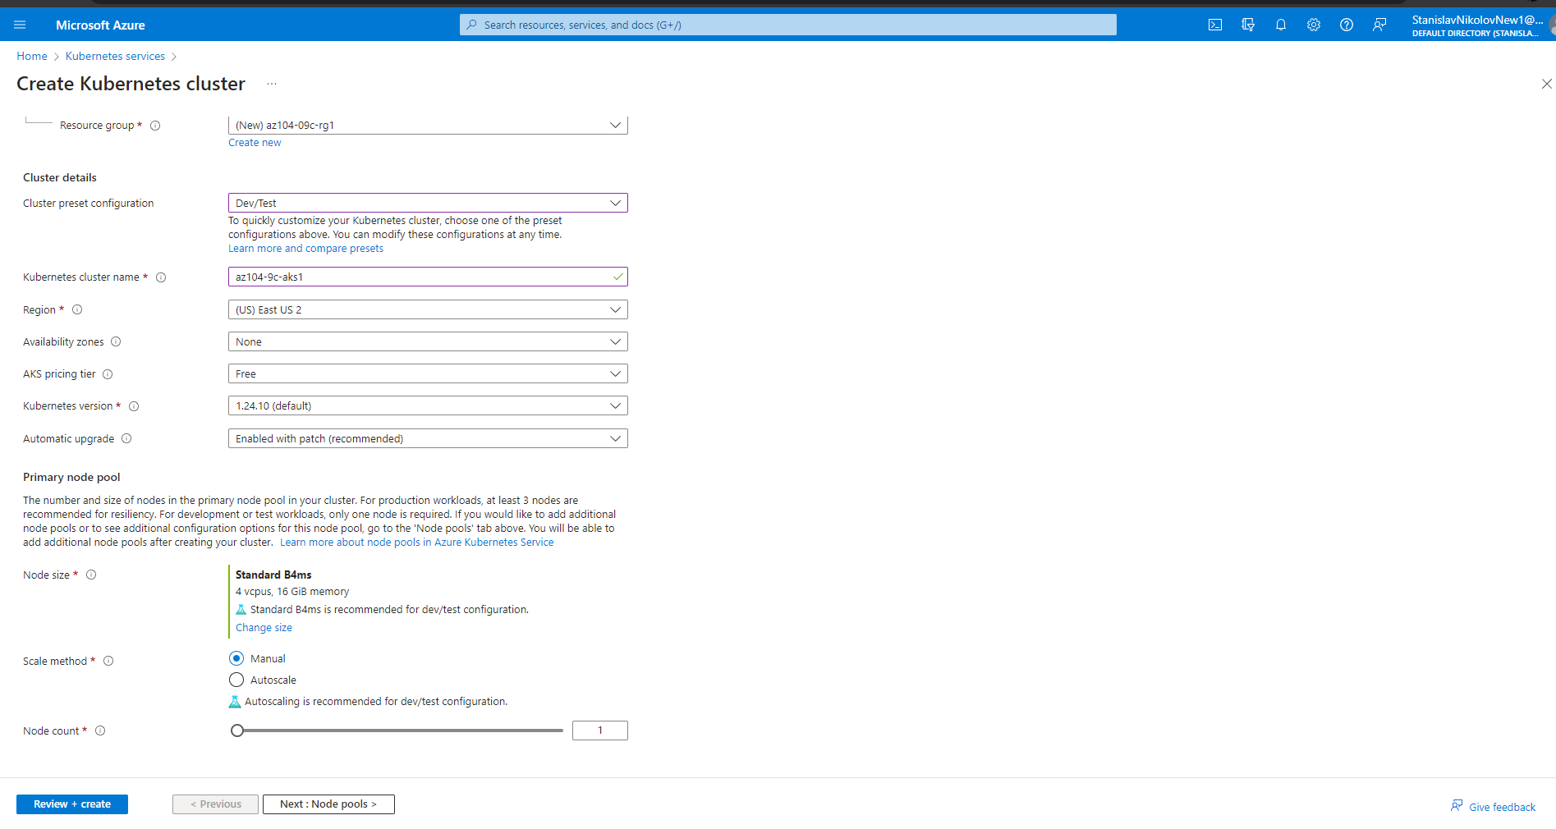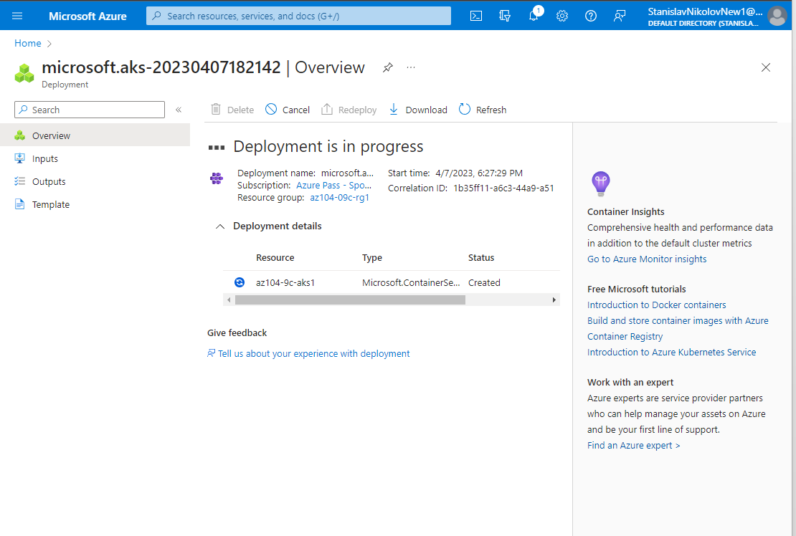

* + Deploy an Azure Kubernetes Service cluster

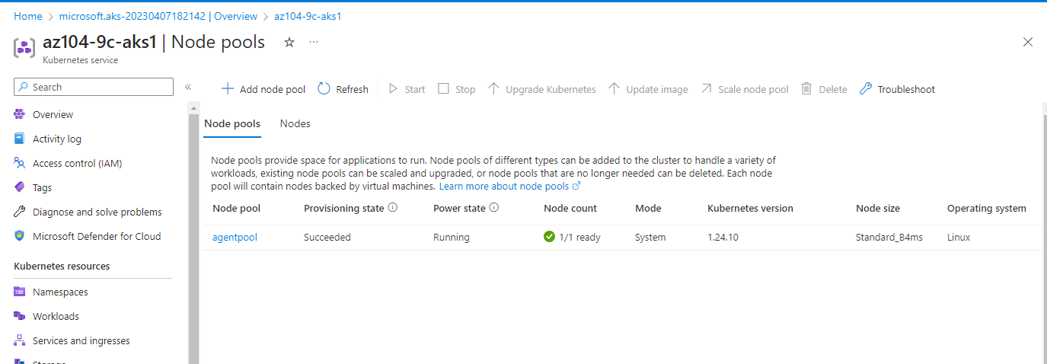

* + verify that the cluster consists of a single pool with one node.
* Task 3: Deploy pods into the Azure Kubernetes Service cluster.
  + In this task, you will deploy a pod into the Azure Kubernetes Service cluster.

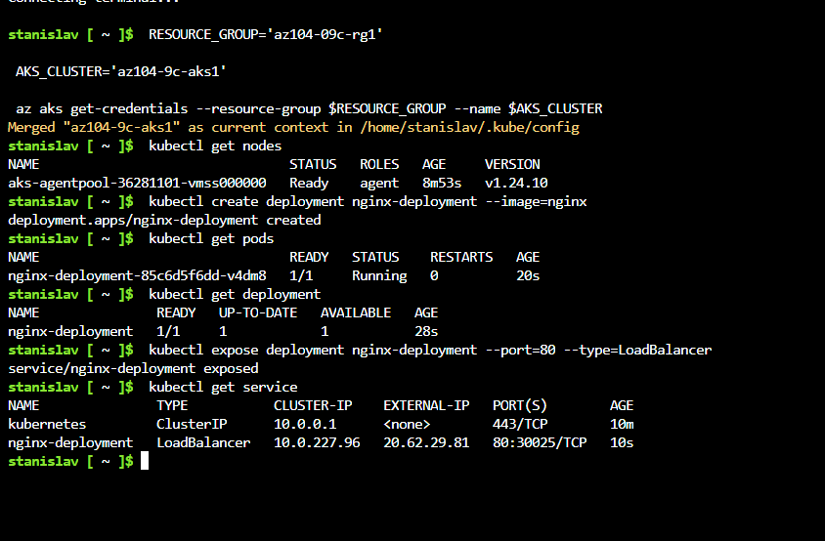

* + pod available from Internet

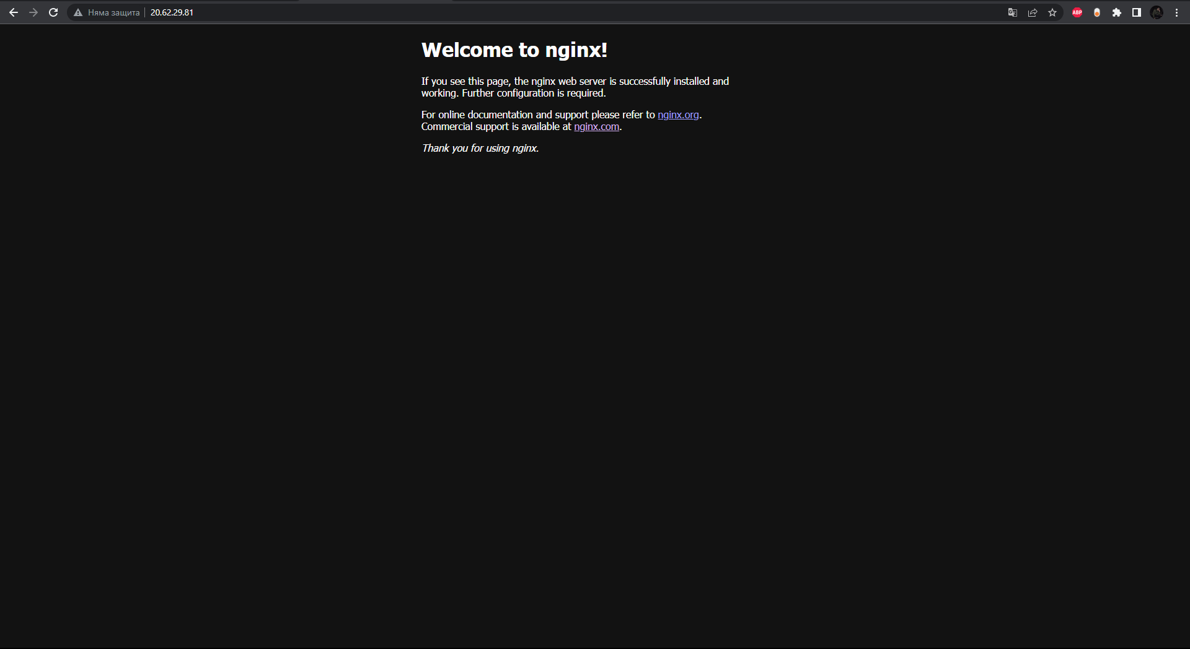

* + Verify that the browser page displays the Welcome to nginx! message.
* Task 4: Scale containerized workloads in the Azure Kubernetes service cluster.
  + In this task, you will scale horizontally the number of pods and then number of cluster nodes.

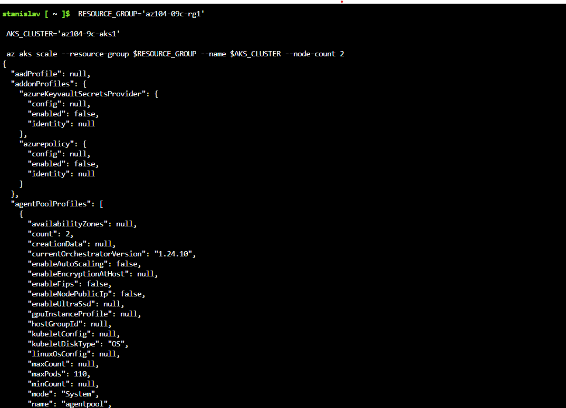

* + the following will scale out the cluster by increasing the number of nodes to 2

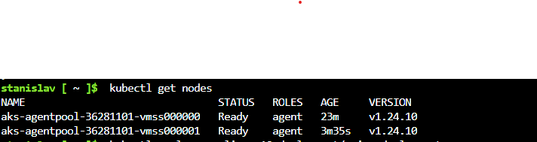

* + verify that the number of nodes increased to 2.

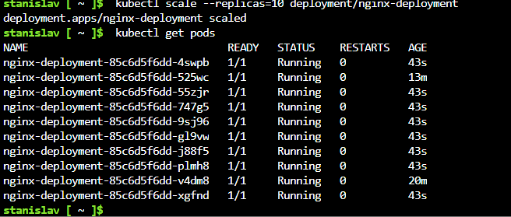

* + verify the outcome of scaling the deployment

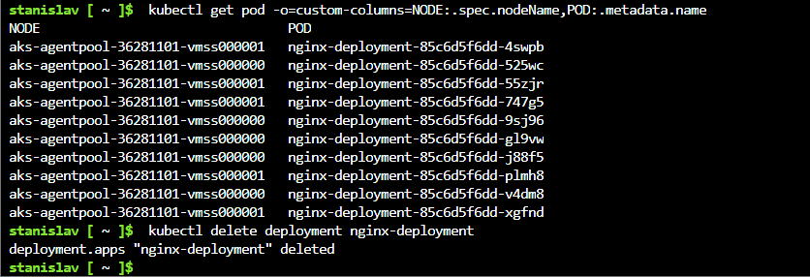

* + review the pods distribution across cluster nodes